Group Name: Genesis

Name of Members USI:

Kelvin Morrison 1028679

Noel Farley 1027234

Valon Madramootoo 1028391

Zhi cheng su 1028141

Ryan Wilson 1028654

Lecture Girendra Persaud



Database Requirements

Specification

Time tracker 1.0

30⁰N Travel Service

Prepared: by Kelvin Morrison

Date: October 15th, 2018

Revision Sheet

|  |  |  |
| --- | --- | --- |
| **Release No.** | **Date** | **Revision Description** |
|  |  |  |
|  |  |  |
| Rev .0 | 09/12/18 | Content adhere to relevant parts of the template |
| Rev .1 | 10/15th/18 | E-R and Relationship Diagram was added |
| Rev.2 | 11/02nd/18 | Functional Specification was added, and some design features was modified |
|  |  |  |
|  |  |  |
|  |  |  |

Table of Contents

Sign offs 5

Introduction 7

Problem Statement 7

Purpose 7

INTENDED AUDIENCE AND READING SUGGESTIONS 8

Scope 8

System overview 9

DATABASE ADMINISTRATIVE INFORMATION 11

Responsibility 11

User class and Characteristics 11

User Class 1 – Owner 12

• Functional requirement 12

Users Class 2- Owners and Administrators 12

• Functional requirement 12

Users Class 3- Drivers 13

• Functional requirement 13

Operating Environment 13

Storage Requirement 13

Functional Requirements 14

Distributed Database: 14

Client/Server System 14

User Interface 14

NONFUNCTIONAL REQUIREMENTS 15

Performance requirements 15

E R Diagram 15

Normalization 17

Safety Requirements 17

Security Requirements 17

Software Quality Attributes 17

Implementation 19

Phase one 19

Phase 2 19

Phase 3 19

Error Handling 20

Data losts 20

Accidental Data Deletion (Don't delete data just hide) 20

Power failure 20

Hardware failure 20

Purpose 21

Required Hardware /software 21

User Views 22

• Class 1: Owner/ Administrator 22

• Class 2: Managers/ dispatchers 22

• Class 3: Drivers 22

Operational processes 22

Application Functionalities 23

Acronyms and Abbreviations 25

Points of Contact 26

Information 26

Task for developing team 27

# Sign offs

We have carefully assessed the Database Specifications for the (Time Tracker 1.0). This document has been completed in accordance with the requirements of 30⁰ N System specifications for Development Methodology.

MANAGEMENT CERTIFICATION - Please check the appropriate statement.

______ The document is accepted.

______ The document is accepted pending the changes noted.

______ The document is not accepted.

We fully accept the changes as needed improvements and authorize initiation of work to proceed. Based on our authority and judgment, the continued operation of this system is authorized.

______________________________ _____________________

NAME DATE

Project Leader

______________________________ _____________________

NAME DATE

Operations Division Director

______________________________ _____________________

NAME DATE

Program Area/Sponsor Representative

_______________________________ _____________________

NAME DATE

Program Area/Sponsor Director

_____________________

NAME DATE

Program Area/Sponsor Director

# Introduction

This document defines the normative content of the software requirements specification. Organization of the information items in the document such as the order and section structure may be selected in accordance with the project's documentation policies.

## Problem Statement

30 ⁰N is a taxi service that estimates its charges base on the time it takes to travelled from one point to another.

However sometimes the drivers of the company vehicles forget to log the time they start the journey, and this causes some problems since a customer cannot be charged fairly.

Furthermore, customers are also complaining that some drivers are taking the longest route and wasting their time. So, Mr. Zod the owner and CEO of the company will like the implementation of a system to keep track of time while managing the route of travelled.

## Purpose

The goal of this document is to give detail description of the Time Tracker 1.0 database and all other components that are required for its optimal performance it also describe all functional and nonfunctional requirements of the time tracker 1.0 application for 30 ⁰N.

## INTENDED AUDIENCE AND READING SUGGESTIONS

This Project is a prototype for the Time Tracker 1.0 and is therefore restricted within 30˚N and the developing team.

## Scope

The “Time Tracker 1.0” (TT 1.0) database is intended to interact with a mobile base GPS application and other mobile time keeping hardware. It will automate the time keeping process. This function will intercorporate with a GPS road mapping application that will help drivers find the closest possible route to their destination. The TT 1.0 will also calculate the charge for the service delivered and print out an invoice for the corresponding service while keeping a digital log of all transactions.

# System overview

The Time Tracker 1.0 database is intended to interface with three level of users. Owner, Management and the drivers of the company vehicles.

All data related to customers travelled will be capture and recorded on a web base server, management is required to set and adjust their hourly rates.

A mobile GPS-Navigator (maybe just a phone app?) software application will interact with the database about vehicle location and route of travel, it is required that the necessary hardware be installed onboard the company vehicles that is intended to log data in the Database.

The mobile application requires both Internet and GPS connection to fetch and receive information about time of travelled and closest possible route. Between drivers and the database.

The major features of the Time Tracker 1.0 Database system are shown in the entity relationship model below. (ER model)

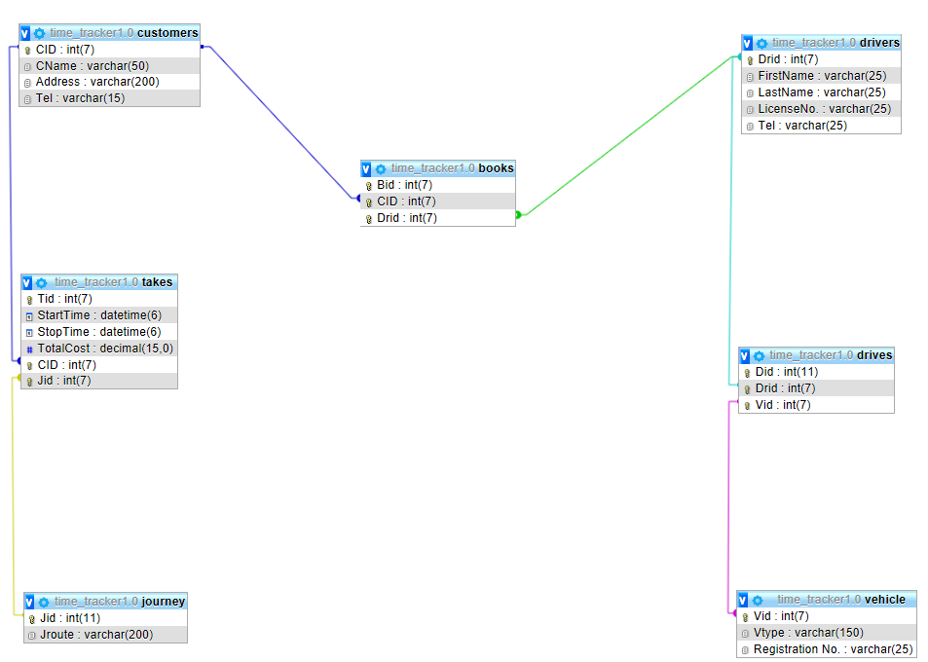

Two drivers tables?

books - reservations ?

Takes?

# DATABASE ADMINISTRATIVE INFORMATION

## Responsibility

The Owner Of 30 ⁰ N will be responsible for the management and overlooking the database. All administrative functions will be carried out by staff or any organization specified by the owner of the entity.

## User class and Characteristics

A first-time user of the system must be giving login privilege by an upper level staff. While these privileges are not granted, if a user is continuously trying to log in, the system will flag the unauthorized use while alerting management about the security breach and make a log of the time and devices IP that attempt to gain entry.

Every user that interact with the system will have access to different functions base on the level of privilege granted to them, User can set the mobile application to his/her preferred language.

Instruction about route of travel and time will displayed base on mopping data stored in the data base.

The System will interact with three level of users:

* User Class 1- Owner of Entity
* User Class 2 - Entity Owner and administrators
* User Class 3 – Drivers

Users at each level of the system will have access to different user functionality specific to their job requirements. (Not Bad)

User Class 1 – Owner

* Functional requirement
* Set Access level of other users.
* Has the authority to add or remove user from the system.
* Manage and regulate the entire database.
* The rights to permanently delete any users.

Users Class 2- Owners and Administrators

* Functional requirement
* Have the responsibility for regulating the hourly rates in the database.
* Creating logging for level three users.
* Keep track of the location of vehicles.

Users Class 3- Drivers

### Functional requirement

* Log in to the mobile device that interface with the database set destination.

## Operating Environment

The operating environment for the Time Tracker 1.0 is listed below.

Web base server: Apache

Operating system: Windows/Android/IOS

Database: MYSQL database

Platform: PHP/ MYSQL:

Backup: Cloud and local server

## Storage Requirement

It is estimated that the database will require a terabyte (1024 GB) of data storage space on start up. More storage space may be required due to maintenance, update and storage of mopping and travelling data.

# Functional Requirements

## ****Distributed Database:****

A single application should be able to operate transparently on data that is spread across a variety of different databases and connected by a communication network This is necessary for future Expansion.

## Client/Server System

The architecture design of the Time Tracker 1.0 will feature both a client and Server application.

## User Interface

Both Client and Server will have separate means by which they are access

# NONFUNCTIONAL REQUIREMENTS

## Performance requirements

These are the steps involved to perform the implementation of TT 1.0 database

## E R Diagram

The E-R Diagram constitutes a technique for representing the logical structure of the database in a pictorial manner. The analysis is used to organize the data as a relation, normalizing relation and obtaining a relation database.

* **Entities:** Specify distinct real-world items in an application.
* **Attributes:** Specify properties of an entity and relationships.
* **Relationship:** Which connect entities and represent meaningful dependencies between them.

ER Diagram (should contain Variable Types?)

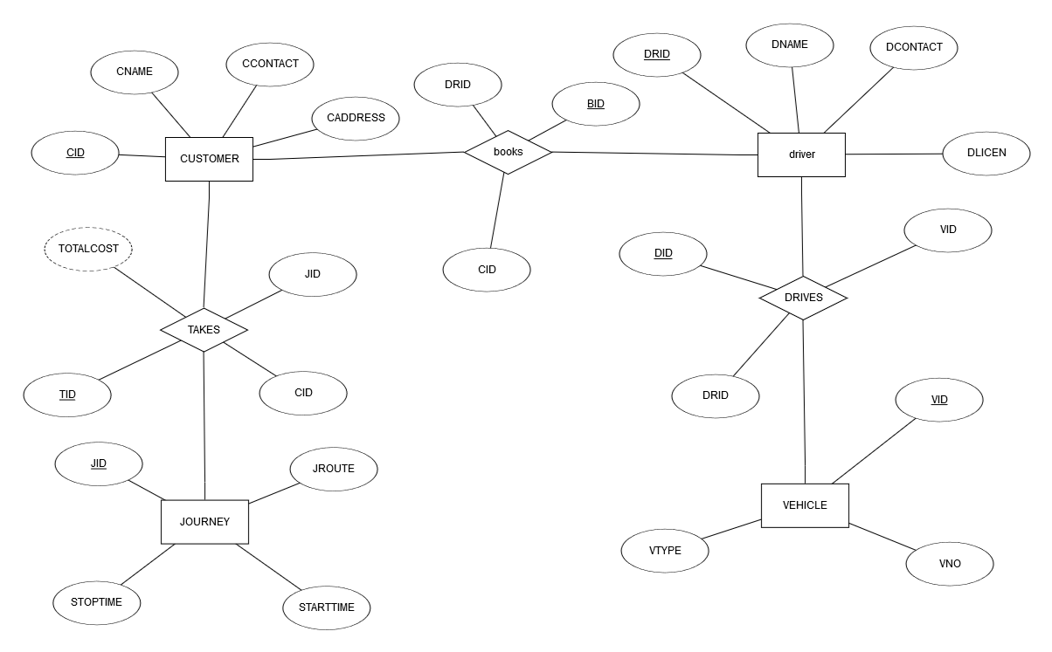

(Ask question in lab, we can discuss the data flow)

## Normalization

The means of ensuring that information is only stored once. Storing the same information several times will leads to wastage of storage space and increase in the total size of the data stored.

## Safety Requirements

Are the means of putting systems in place to back up and recover system data to be use in the event of extensive damage to the database due to catastrophic failure.(these will be the means to bring the database back to the state it was before any failure due to sabotage, fire or flood or any natural disaster)

## Security Requirements

Involves all actions taken to ensure safety and integrity of the database. (This involves the implementation of the necessary procedures to zero tampering or malicious deletion of data from the database or any other action that will corrupt or otherwise hinder the normal function of the database)

## Software Quality Attributes

* **AVAILABILITY:**

Information regarding access rout should be readily available on request.

* **CORRECTNESS:**

All data regarding to route and charges should be accurate

* **MAINTAINABILITY:**

The administrators or manager in chargers should be able to easily maintain or correct charge data.

* **USABILITY**

The mobile interface should be easy to navigate.

# Implementation

The system will function on MYSQL and be deployed in three phases

## Phase one

* **Installing and integrating of mobile devices on all vehicles**

During this process the GPS navigation system, time tracking hardware and the mobile broadband devices will be placed onboard the vehicles also sample street mapping data will be collected.

## Phase 2

* **Implementation of a time management system**

The clocking system for the time tracking hardware will be integrated to work along with the GPS Navigator. Testing will be done during this phase to ensure the clocking system function at it was intended.

## Phase 3

* **Capturing and Billing**

The prices are set and coordination with the clocking system to generate charges. Recording of GPS data and generating invoices base on time of travel.

# Error Handling

## Data losts

The database will be systematically backup to reduce lost of data. It will require an independent server to run on.

## Accidental Data Deletion (Don't delete data just hide)

All Deleted Data will remain in a recycle bin for twenty 20 days before permeant deletion

## Power failure

A backup system along with a generator will be employed.

## Hardware failure

In the event of fire, flood or any other disaster all data could be recovered from an offsite server

Logical Database design

Functional Specification

## Purpose

This part of the document will give details to how the software will operate in its environment and describe all other components that are require for its full performance.

## Required Hardware /software

|  |  |
| --- | --- |
| Mobile Broadband Modem | This is for the internet connection for the mobile devices onboard the vehicles, every vehicle will be required to have one. |
| GPS Navigation software and hardware | Require for fetching data about a vehicle location to the database and give detail about best possible route to a destination. |
| Time Tracker and invoice printing hardware | It is required to start and stop the timing process and printing of the invoices it will also display the time in rear time in the vehicle. |
| Web Server | “Apache” this will deliver the web interface to log into the database and allow for all front-end functionality. |
| MySQL database | Use for storage and retrieval data by all connecting components |

## User Views

Each user will have a different view of the database when log into the web application. These views will depend on the user privilege available to that user class:

### Class 1: Owner/ Administrator

When this class of user log into the web application they will be given the privilege to add, update or delete any account. Also, all administrative function is available to this class of user. Only user with the rights to add or delete data

### Class 2: Managers/ dispatchers

When log in they will have access to vehicle location and all drivers’ activities also they will have the privilege of setting and suspending login session for lower level staffs.

### Class 3: Drivers

These class of users only privileges are to login and out of the system, making searches, logging time and requesting invoices for services delivered.

### Operational processes

Driver are required to log into the mobile interface before starting his/her tour of duty,

When a customer call to book a driver, the dispatcher will send the assignment to the closest possible vehicle to the customer location this will be don’t via the mobile interface aboard the vehicle.

When the customer board the vehicle and instruct the driver of their intended destination the driver will enter a search, to locate the closest possible route and start the time tracking application.

When the customer arrived at their destination the driver stops the time tracker and request a printout of an invoice (invoice is calculated based on some formula times the time it takes to travel from point a to b)

This entire process is capture and recorded in a database.

### Application Functionalities

For Owner/Administrator

* Login/ register
* User information
* Able to trace vehicle location
* Adjust charges formula
* Able to check if a driver is on or off duty
* Add or delete any user

For Manager/ Dispatchers

* Login/ register
* Create login for lower level user
* Able to check if a driver is on or off duty
* Send out dispatch

For drivers

* Login/register
* Start and stop the timer

Start

User login to the

application

allow the user to

check the mobile

interface

Show where is

the customer

located

Search the

destination in the

application

Find the optimal

route

Start the time

tracking

Stop the time

tracking(when

customer

reaches to

destination)

Print the invoice

END

# Acronyms and Abbreviations

|  |  |
| --- | --- |
| **Acronyms** | **Abbreviations** |
| GPS | Global Positioning System |
| TT | Time Tracker |
| DESC | Description |
| DBMS | Database Management System |
|  |  |

# Points of Contact

Computer Science Department

## Information

Kelvin Morrison

Email [kelvin_morrison97@yahoo.com](mailto:kelvin_morrison97@yahoo.com)

Tell (592) 688-8913

Noel Farley

Email [vest.94679@gmail.com](mailto:vest.94679@gmail.com)

Tell (592) 6471401

Ryan Wilson

Email [Ryanwilsoni@yahoo.com](mailto:Ryanwilsoni@yahoo.com)

Tell (592)6118906

Zhi Cheng Su

Email [rivailleheichou414@gmail.com](mailto:rivailleheichou414@gmail.com)

Tel (592)6486694

### Task for developing team

|  |  |
| --- | --- |
| Members Name | Delegated task |
| Zhi cheng su | MYSQL management |
| Noel Farley | Web application Design |
| Valon Madramootoo | Web design |
| Kelvin Morrison | Design Database |
| Ryan Wilson | Design Mock up diagram |